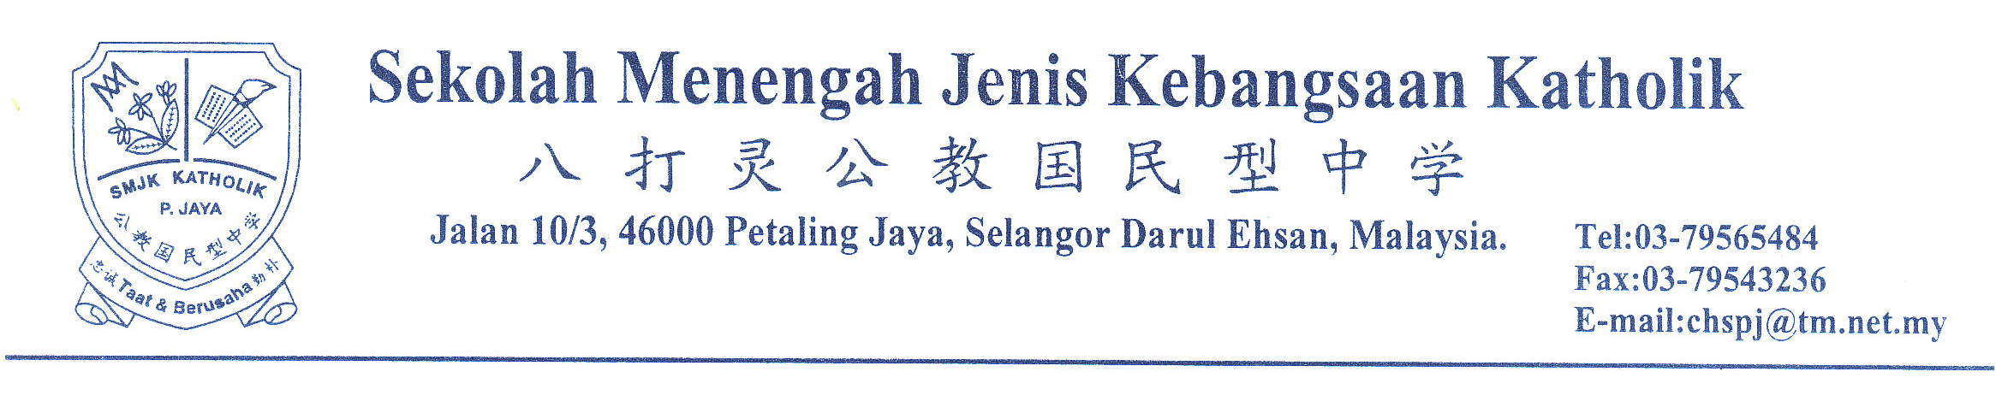To: Shelter Home for Children 7th November 2010
Dear Sir/Madam,
Request Involvement In The First AIDS Kit Project: Outreach Program on HIV/AIDS
Regarding the above matter, we are pleased to inform you that Catholic High School Prostar Club is conducting a project, First AIDS Kit. A newly founded youth organization that empowers youth that are at risk of HIV/AIDS infection by providing them appropriate knowledge about HIV/AIDS through peer education.
2. First and foremost, this is an international project which consists of three different countries (Malaysia, Philippines, Thailand). Malaysia is where the pilot project will take place before expanding to the other nations. In this case, the Catholic High School Prostar club has been chosen to be the foundation of this pilot project in Malaysia.
3. On January ^{22nd}, 2011, we will provide peer education on HIV/AIDS to the underprivileged teenagers and collaborate with 2-3 shelter homes. It will be held in the afternoon and the time is to be confirmed soon (estimate 4 hours). After contemplation and surveys, our survey team has come into a conclusion that we would like to invite you to participate in this project.
4. For your concern, HIV/AIDS infected cases are rising among teenagers, yet it is noticeable that our civilians are still not alert on this issue due to their limited knowledge of this fatal virus/disease. Therefore, we hope that we could contribute regarding this issue by educating teenagers about HIV/AIDS.
5. For your information, Malaysian AIDS Council (MAC) has agreed to provide us full technical support for the whole course of this project. This project has also been awarded 2000USD by Microsoft.
6. We believe that teenagers in your organization will benefit from this project, and we really hope that your organization will fully support us and let us be a part of this meaningful project. If you would like to know more about this project, kindly contact our student representatives, Ng Hui Xin (012-366 3935), Frankie Lai Teck Ming (016-286 6017) or you can contact our teacher advisor Ms. Shanbagadevi (017-873 2023).
7. Lastly, I enclosed here our project proposal and the approval letter from MAM.
We look forward to your participation in this project. Your cooperation in this matter is very much appreciated. Please reply by 30th November.
Thank you.

Prepared by, Approved by,

au

_____________________ _____________________
(CHRISTINE CHEE) (NG HUI XIN)
Project Community Coordinator II, Project Coordinator,
Catholic High School. Catholic High School.

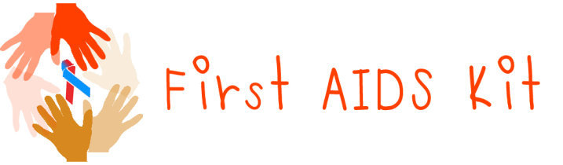

1. Objectives
- Empowering vulnerable and at-risk youth as channels of HIV/AIDS information through peer education.
- Developing behavior change communicators among vulnerable young people and through peer education help them make informed decisions to shape their own response that address their risk to HIV/AIDS.
- Empowered youths making a difference through delivering HIV/AIDS information and services, reducing their risks and being role models of positive behavior, sustaining their local response through peer education.
2. Project implementation
(i) Date : 22nd of January, 2011
(ii) Time : 1pm -5pm
(iii) Location: Shelter Home for Children
3. Target
12 – 18 years old

4. Activity
Volunteers from our school will complete the outreach session (HIV/AIDS Information session/Peer education) will be conducted at your organization. We hope that our outreach session will advance your teens that under your organization.

5. Schedule

1. Pre & post test & Warm up/ Ice breaking games
2. Introduction to HIV/AIDS
a. Definitions
3. Who can get HIV/AIDS – behavior
a. Activity 1 (Role play) – status, occupations
4. Transmission:
a. HIV/AIDS sketch – the immune system
b. Three modes of transmission – How is HIV transmitted.
- High concentration, Low concentration
i. Blood
ii. Semen/vagina fluids
iii. Breast milk
c. How HIV is NOT transmitted
Break time
(Energizers-games)
5. Prevention
- Blood to blood – universal prevention
- Mother to child
- Sex (unsafe) - ABC
6. *Condom demonstration
7. HIV testing – antibody test
a. HIV anti body test – HIV positive, HIV negative
b. Pre & post test counseling
8. 8. Living with HIV
a. Virus itself: Treatment – Level A, B, C
b. Emotion/ mentally disorder: Support groups

*Under agreement of caretakers

MAC/ ADVOCACY/ Training/ 2010

7hb Oktober 2010

Puan Lee Kim Lai
Sekolah Menengah Jenis Kebangsaan Katholik,
Jalan 10/3, 46000 PJ
Selangor.

Puan,

PER : Surat Sokongan Bagi Program “ First AIDS Kit”.

Dengan segala hormatnya izinkan saya merujuk kepada perkara di atas

2. Majlis AIDS Malaysia (MAM) ingin mengucapkan terima Kasih kepada Puan bagi mengalakkan program berkaitan HIV/AIDS, dilaksanakan oleh murid-murid sekolah Puan. MAM amat bersetuju dengan program yang bakal dilaksanakan, dan berjanji akan memberi sokongan serta bantuan teknikal bagi menjayakan program ini.

3. Untuk makluman Puan, statistik di Kalangan remaja semakin meningkat dan berada dalam keadaan yang membingbangkan. Oleh itu, program seumpama in harus diberi keutamaan bagi memberi kesedaran serta pengetahuan kepada golongan remaja, supaya mereka dapat melindungi diri mereka daripada terjerumus kedalam aktiviti-aktiviti yang tidak bermoral.

Dengan ini, MAM ingin merakamkan ucapan terima Kasih sekali lagi kepada pihak Puan. Untuk keterangan lanjut, pihak Puan boleh menghubungi En. Gunasegaran dari Bahagian Advokasi MAM di talian +603-4045 1033 sambungan 208. Kerjasama dan sokongan pihak amat dihargai.

Sekian terima kasih.

Yang benar,
_____________________
Datuk Mohd Zaman Khan
Presiden
Majlis AIDS Malaysia

